
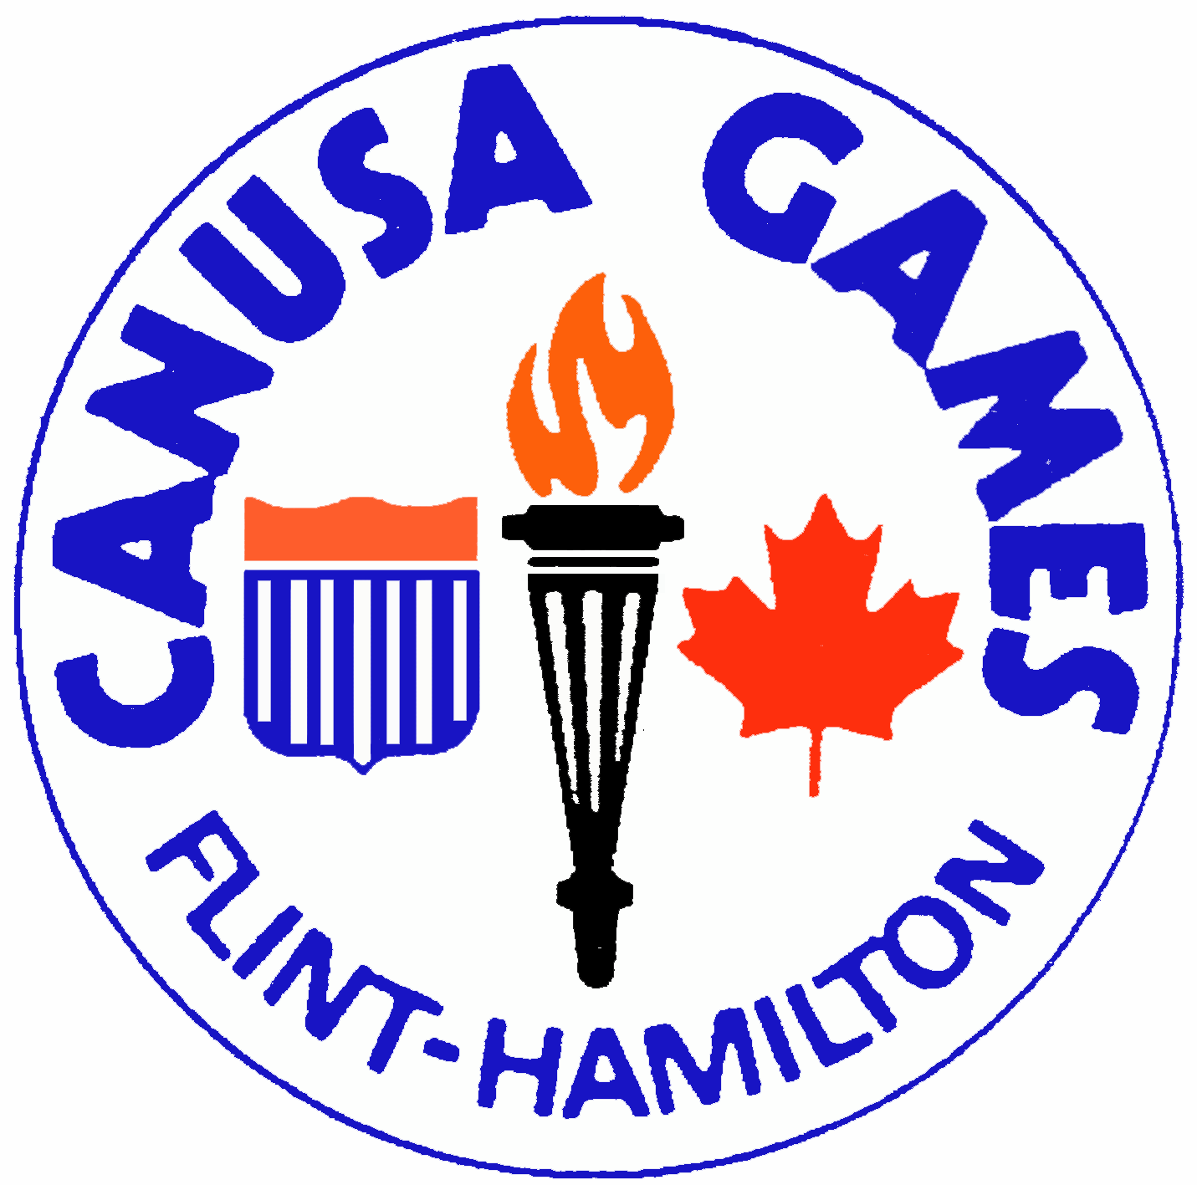
2013
Flint Olympian & CANUSA Games

**TURN-IN TIMELINE**

Turn-In Date

- Flint Olympian Games Medal Request Friday, June 28, 2013
- Awards Dinner Invitations Monday, July 8, 2013
- Pat Patterson Nominations Monday, July 15, 2013
- James A. Littell Nominations Monday, July 15, 2013
- CANUSA Coaches Recommendations Friday, July 19, 2013
- CANUSA Orientation Request Monday, July 22, 2013
- CANUSA Practice Schedule Monday, July 22, 2013
- CANUSA Participant Shirt Request Immediately after your
FOG event/ playoff

